**S.A.F.E course guide**

Welcome to the S.A.F.E e-learning course, designed specifically for adults who have experienced domestic abuse. S.A.F.E stands for Safety, Awareness, Freedom and Empowerment. The course takes approximately 2 hours to complete, but you can complete it at your own pace and in bite-sized chunks. Your progress will be saved automatically when you sign out, so you can pick up where you left off when you log back in.

There are two versions of the course available. Both versions cover the same material, but one includes an extra module about the impact of domestic abuse on children. We recommend accessing this version if you have children, but it is also available to those without children.

**The S.A.F.E course content includes:**

* The different types of abuse
* Some of the common patterns of domestic abuse
* Myths and truths about domestic abuse
* Healthy relationships and core values
* Brief overview of the Impact domestic abuse has on children.
* Potential warning signs of abuse
* Dealing with grief and loss
* Moving on process … and much more!

Please ensure it is safe before engaging with this e-learning course. Each section includes an escape button that redirects to the BBC News website, providing an extra safety measure in case you need to leave the site quickly. If privacy is a concern, we suggest deleting browsing history after use.

Please note that due to the sensitive nature of the content, some topics in this course may trigger distressing emotions. You can take a break from the course and return to it when you feel ready. It is a voluntary course and you are not obliged to complete it. If you require support, please reach out to trusted individuals or professionals. We recommend completing this course in private and avoiding use under the influence of alcohol or when you are feeling emotionally distressed.

**List of useful support services:**

**NHS Mental health support line**: **0800 001 4331**

**Shout – Text service.** Free 24/7 text mental health support service. **Text 85258**

**LDASS – 01522 510041 (option 2)**

**Samaritans - Free** 24-hour helpline - phone **116 123**

**Registering and accessing the S.A.F.E. e-Learning course**

The remaining sections of this user guide explain the steps required to access the S.A.F.E course. The S.A.F.E course is accessible through the Safeguarding Lincolnshire Enable training portal hosted by Virtual College.

Step 1 – Registration

1. Visit the Lincolnshire Safeguarding Children Partnership website: <https://www.lincolnshire.gov.uk/safeguarding/lscp>
2. Click on the Training link:

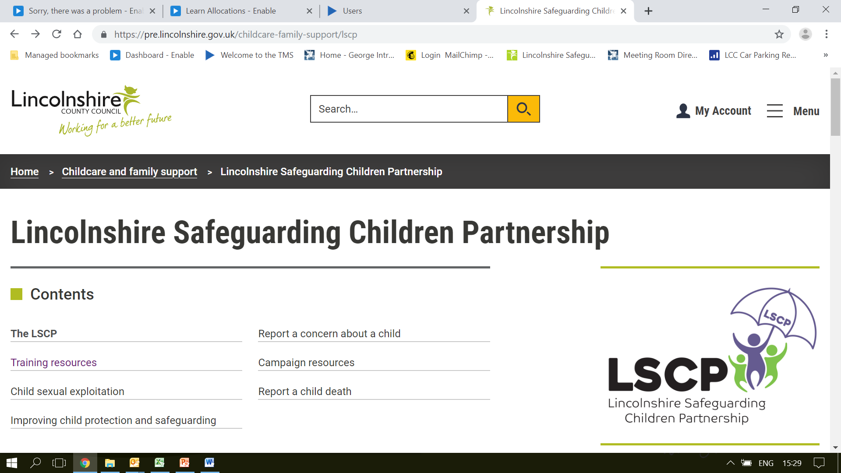

1. Click on the New User Login link to be taken to the registration page to obtain a new learner Record and log in details:
   * The direct URL link is: <https://safeguardinglincolnshire.vc-enable.co.uk/register>

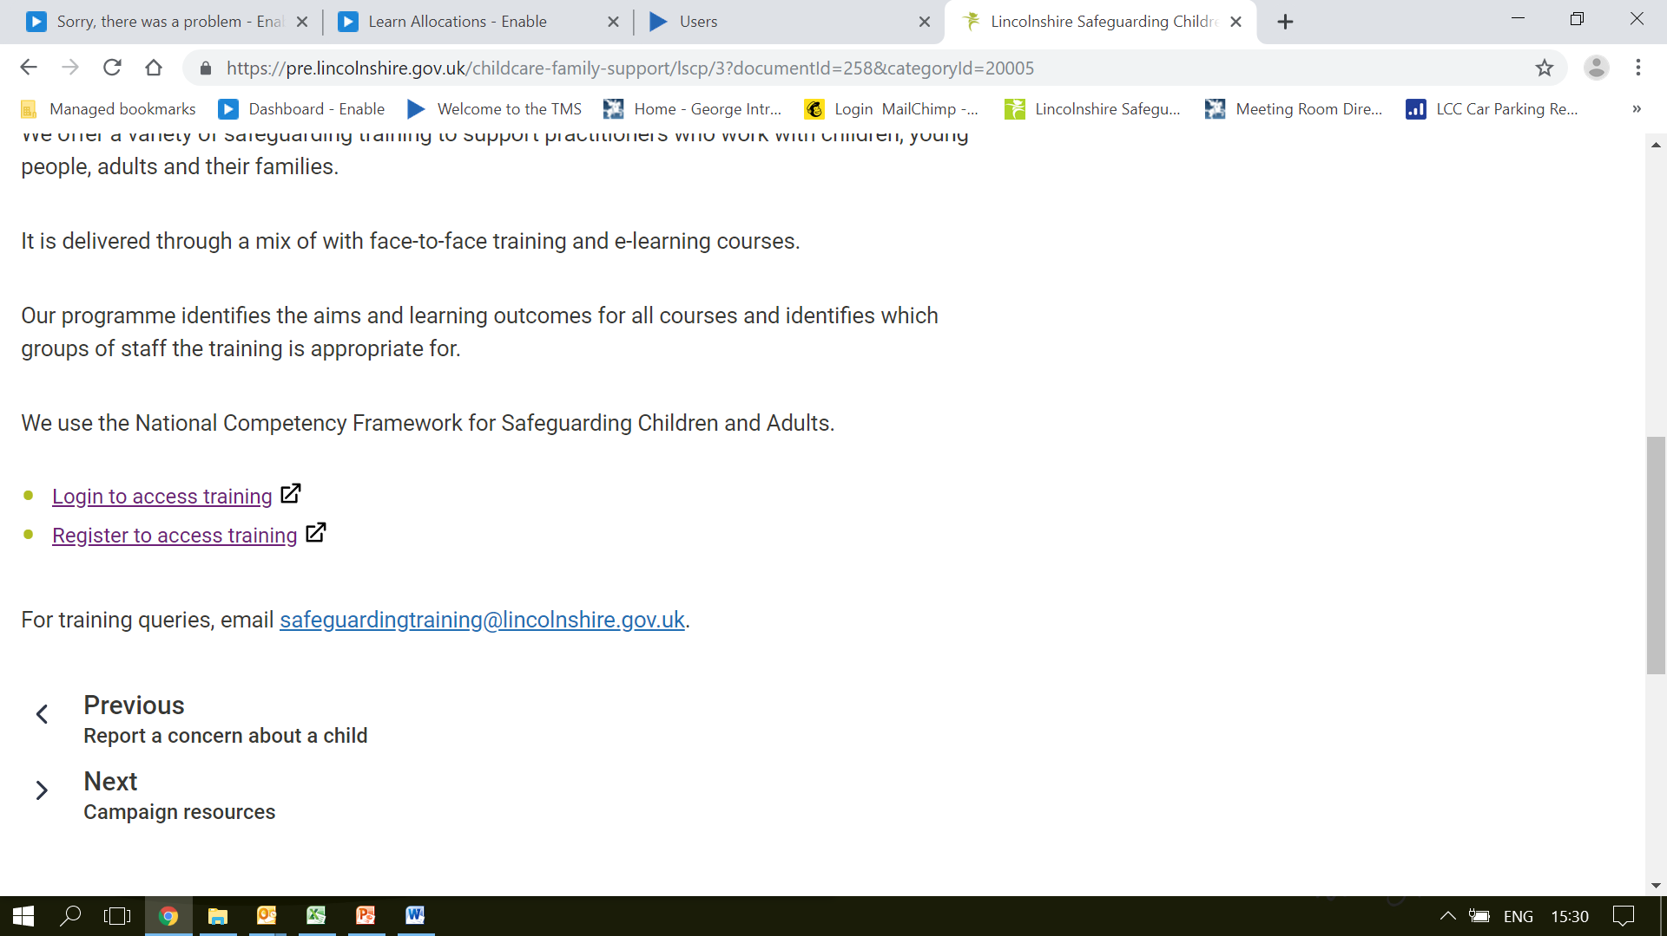

1. Fill in the fields marked with a *

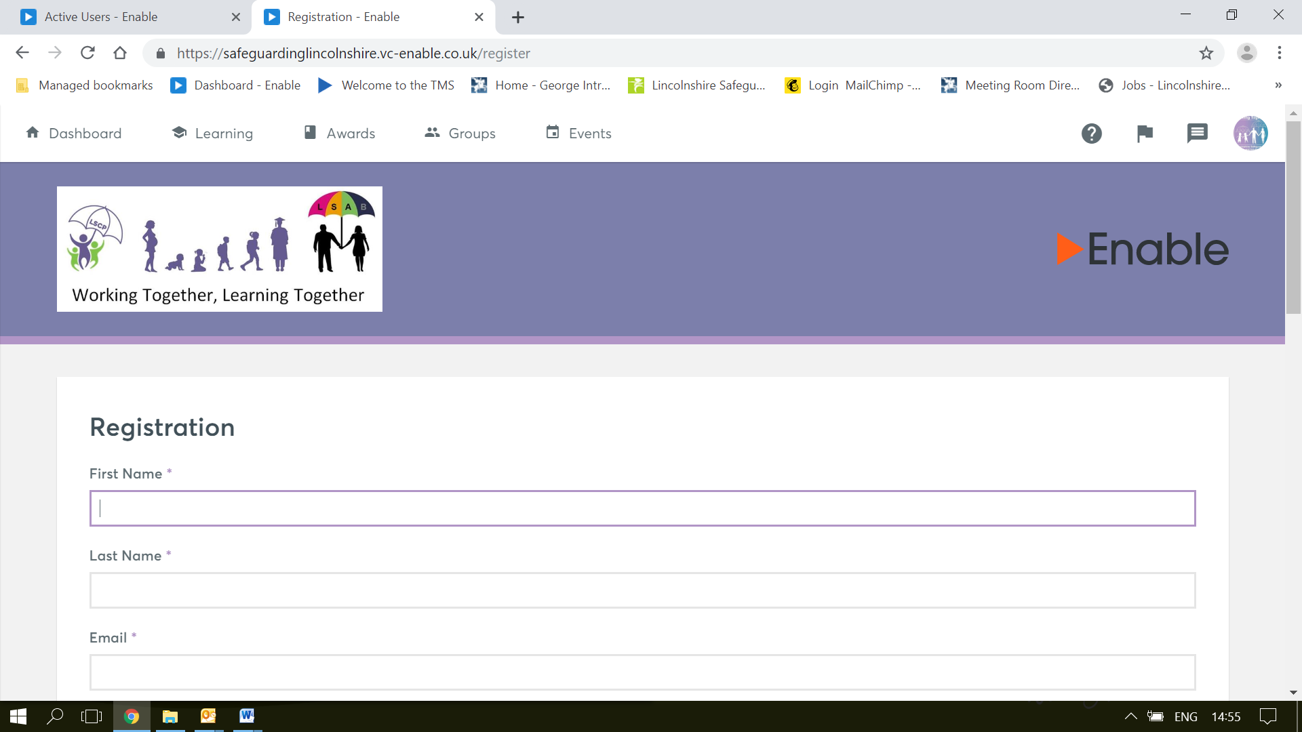

1. Select your groups from the list:
   * The list is long and may take a few minutes to load.
   * The group you will need to select is: **Charity - S.A.F.E Course EDAN**

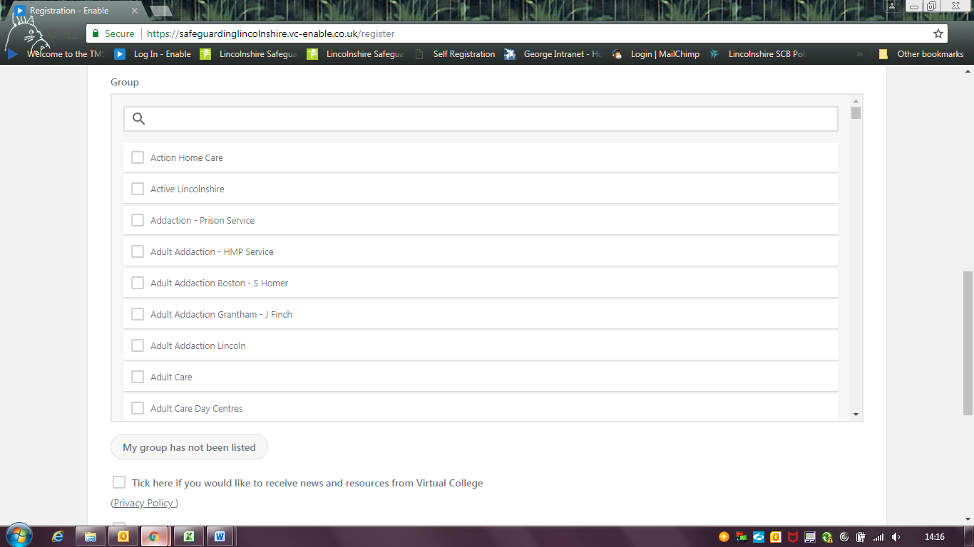

1. Click in the I'm Not A Robot box and then Register at the bottom of the screen to finish:

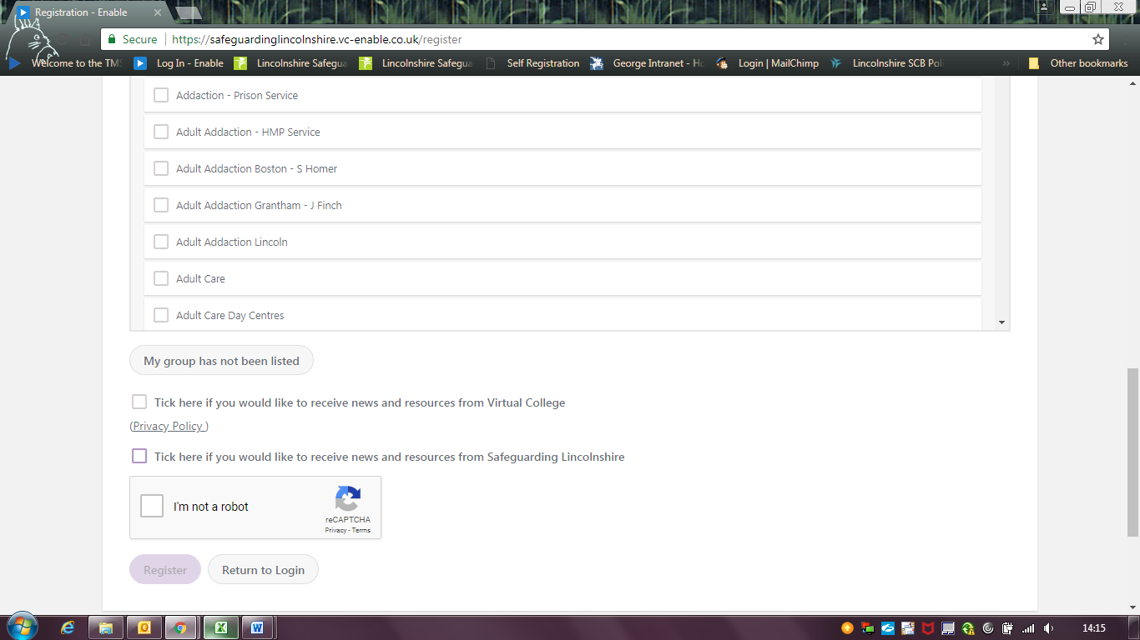

An automatic email from Virtual College will be sent with your log in details. It may take several minutes to come through and please be sure to check your spam/junk inbox.

The email from **Virtual College** will say **‘Welcome to Safeguarding Lincolnshire’**.

The email will provide step-by-step instructions on how to activate your new Learner Record (you have to do this first before accessing the S.A.F.E course).

The instructions in the email will look something like this:

Step 1 - Click on the link provided

Step 2 –Input your username, which has to be your email address.

Step 3 - You will be asked to create a password, then confirm it and click to confirm the account.

You can click the Help & Support link to view a collection of user guides and video tutorials. You can also use the Help & Support link to submit a query. Alternatively, you can call Virtual College on 01943 885095.

You will then automatically be taken back to the homepage.

Accessing S.A.F.E online course -

When Log-in Details have been received.

1. Log in at <https://safeguardinglincolnshire.vc-enable.co.uk>

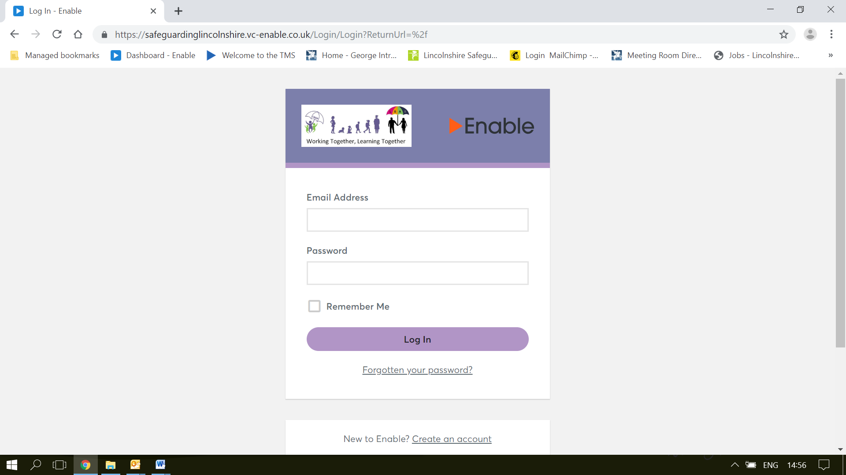

1. Once logged in click on the Learning tile to request e-Learning:

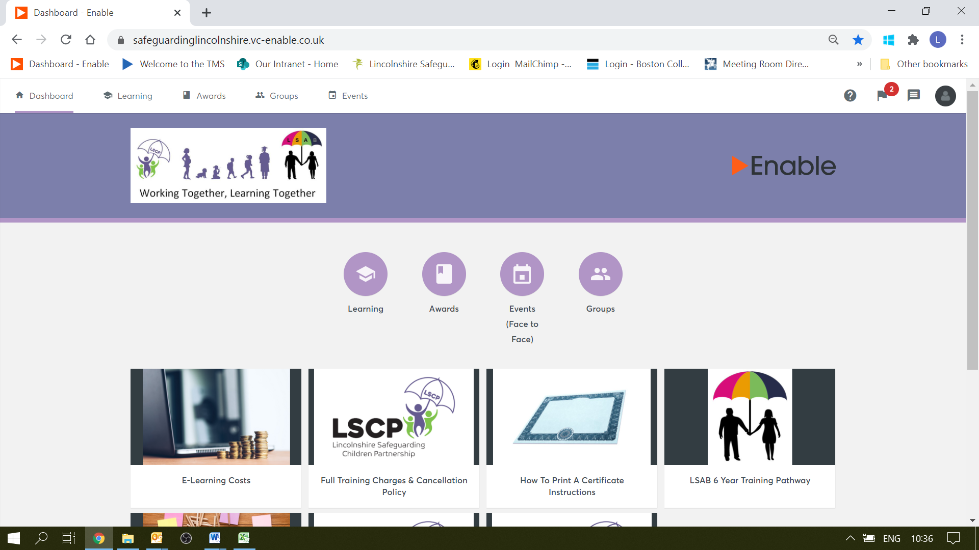

1. You will first see the Active Learning. Scroll down to the Available Learning section. Choose one of the two e-learning courses: Click Start to begin.
   * **S.A.F.E**
   * **S.A.F.E (including learning on how domestic abuse impacts on children)**

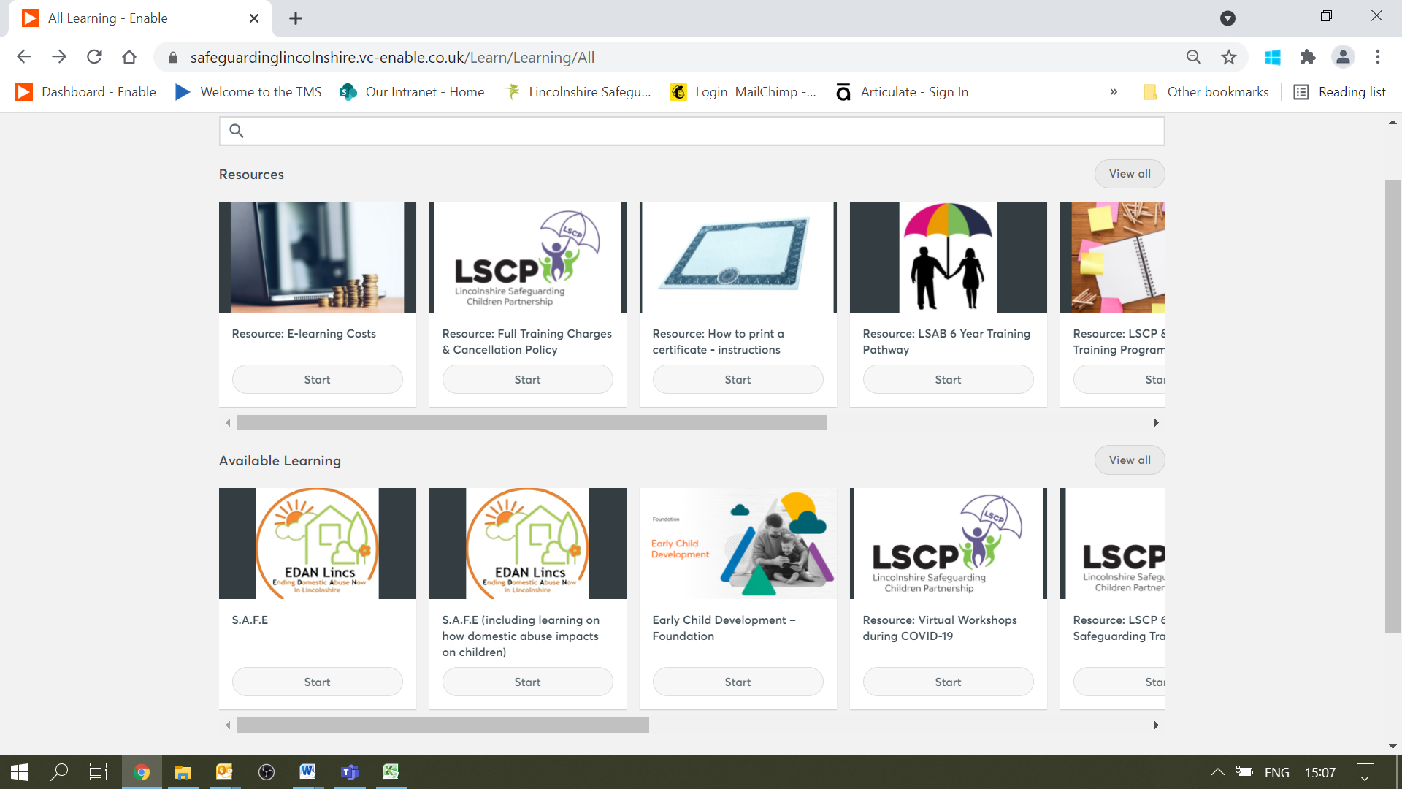

1. This page shows the e-learning course description. Click start:

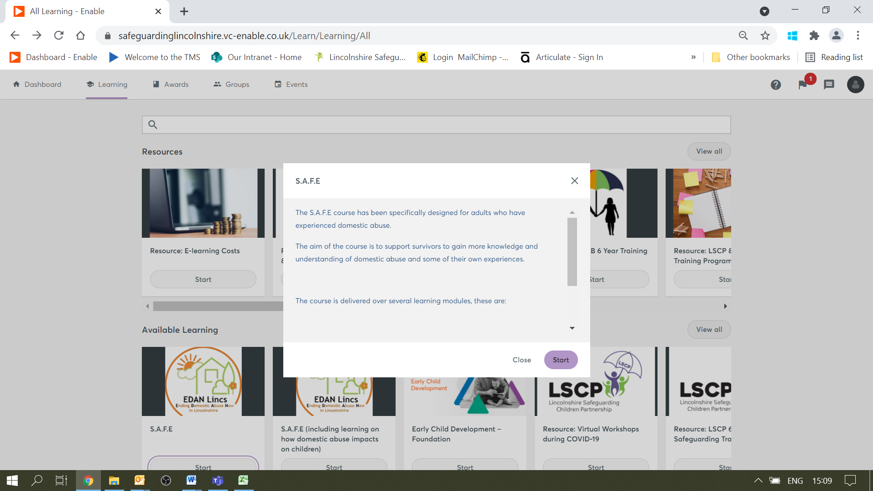

1. Click start to begin the course:

