**Safety Plan to do with children and young people (for parents)**

If you would like to put a safety plan in place with your children, please explore the resource below, the resource is self-explanatory, just follow the steps for safety planning and explore in detail for each area (home, outside, etc.)

Some young people like to do “their own safety plan”, (by following this one), they usually put it in a card format so that they can keep it in their pocket, as a prompt of what to do in case they forget or are too nervous to think.

**Safety Plan**

Explain to your children that it is important for everyone to have their very own safety plan so we can stay safe at all times! They may not ever need to use this plan but it is always better to have one, just in case. Having a safety plan may help them to feel less worried in case anything happens as they will be prepared and will know what to do.

**Home**

Ask your children if they have ever felt scared at home and how it is important to get somewhere safe, where would their safe place be? Some children and young people say that their safe place is: their bedroom, the garden, the garage or a neighbours home.

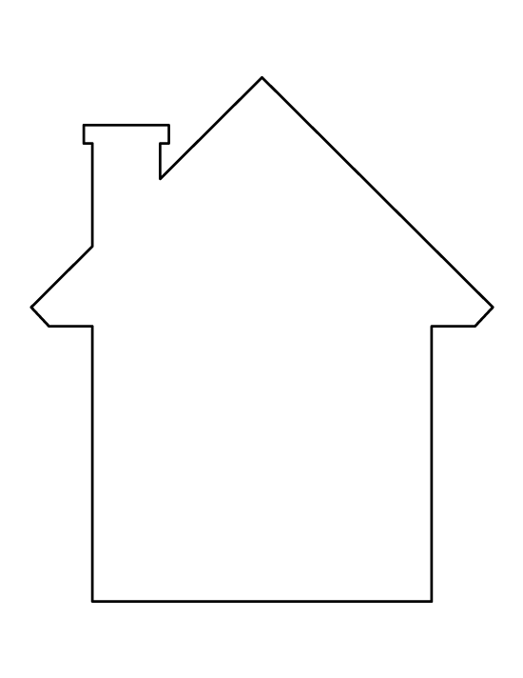

**People**

Explore with your children: in case something was happening to them, which made them feel scared, who could they tell or speak with? Write their names below.

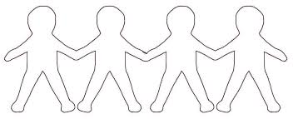

**Outside**

Together, with your children can you think of ways to stay safe if they were away from home? Fill in the scene with answers… example: when walking to and from school, on their way to meet friends, etc.

Teach your children what to do if there is an emergency:

Do they know the phone number they would need to call if there was an emergency?.....................

They (children) would then need to tell them what emergency service they need…



The emmergency services would then need to know what is happening, why may they need to call Them?................................................................................................................................................................................................................................................................................................................................................................................................................................................................................................................................................................................................................................................................................................................................................................................................................................

They would like to know their name…………………………………, age…………… and the address……………………………………………………………………………………………………………………………………………………………………………………………………………………………………………………………………………………………………………………………………………………………………………………………………………………………………………………………………………………………………………………………………………………………………………………………………………………………………….

Practice contacting the emergency services with your children so that if they ever need to make contact, they know which number to call and what to say.